**20IT6205A: AGILE SOFTWARE DEVELOPMENT**

**Home Assignment**

**A.Y: 2022-23**

Name: Konumuri Kalyan Suhas RollNo: 208W1A1226

1. **Name of the project:**

Driver’s Drowsiness Detection Using Computer Vision

1. **Describe the application/ software/ prototype/ product:**

Driver’s Drowsiness Detection using Computer Vision. In this study, we employ computer vision based theory, which enables us to identify driver sleepiness. An alarm sounds, warning the driver, 3 if the driver keeps his eyes closed for more than 1.5 seconds, which is often longer than a typical eye blink. If the driver is still asleep even after the alarm, another sound is made to depict the car automatically sidelining and breaking. Even if the driver is using contact lenses, this technique can still identify their tiredness. The major goal of this initiative is to reduce the percentage of accidents that occur as a result of drowsy driving. As is pretty obvious, the automobile industry is expanding quickly as more and more individuals purchase their own private automobiles. By installing this technology in their vehicles, manufacturers might lower the danger of accidents brought on by sleepiness.

1. **Objectives of application/ software/ prototype TV/ product with respect to HOT analysis framework:**

**HUMAN PERSPECTIVE:**

* This project aims at reducing accidents caused due to driver’s drowsiness with the help of computer vision.
* This not only saves the life of the driver but it also saves the life of other people on the road.

**ORGANIZATIONAL PERSPECTIVE:**

* This provides many profits for the organization as it can be instilled in many automobiles clearly making it very useable and profitable.

**TECHNOLOGICAL PERSPECTIVE:**

* To Train model in such a way that it detects face of a person and also co-ordinates of eyes.
* Implement a novel deep learning approach to execute eye detection frame to frame.

1. **Team Forming: Give the details of your team in the below table format:**

|  |  |  |  |
| --- | --- | --- | --- |
| **Student’s Name** | **Student’s ID** | **Department** | **Electronic-Mail** |
| K. Kalyan Suhas | 208W1A1226 | IT | [kalyan.konumuri@gmail.com](mailto:kalyan.konumuri@gmail.com) |
| M. Shyam Prakash | 208W1A1227 | IT | [shyamprakashmaddineni@gmail.com](mailto:shyamprakashmaddineni@gmail.com) |
| Y. Venkatesh | 208W1A1252 | IT | venkateshyarlagadda621@gmail.com |

1. **Describe the role schema with respect to your project and elaborate on your role:**

|  |  |  |
| --- | --- | --- |
| **Student’s Name** | **Student’s ID** | **Role Schema** |
| K. Kalyan Suhas | 208W1A1226 | Coding & Documentation |
| M. Shyam Prakash | 208W1A1227 | Data Collection & Coding |
| Y. Venkatesh | 208W1A1252 | Data Collection & Documentation |

**My details of my role:**

My role in the implementation of the project was very vital, because although there were several ways of solving this problem we had to use the best suited way in order to get the best suited results, and documentation was the most important aspect of our project so I had to do the documentation of our project in the most precise way in order to assure that we are meeting the level of expectations of the panel members. I also provided constant support to my team-mates which resulted in completion of our project successfully.

1. **Your team is told that if the project it is working on is successfully completed on time, the team will receive a bonus. Five options for bonus allocation are out lined below. Please explain how each option might influence team cooperation, and select the option you prefer:**

|  |  |  |  |
| --- | --- | --- | --- |
| **CASE** | **Personal Bonus (% of the total bonus)** | **Team Bonus (% of the total bonus)** | **How this option may influence team mates cooperation** |
| A | 100 | 0 | It effects the team cooperation as if only a person is getting all the bonus even after the whole team works hard for the project. |
| B | 80 | 20 | This case is almost similar to that of the case ‘A’ but a little bit less as team is getting 20% bonus, but this kind of distribution leads to lack of cooperation in team. |
| C | 50 | 50 | This type of distribution do not lead to any kind of issues and help to maintain the team cooperation. |
| D | 20 | 80 | Since the team bonus is much greater than the personal bonus there will not be any kind of issues and thus team co-operation can be maintained. |
| E | 0 | 100 | Since all the members are receiving the same bonus and complete bonus, team co-operation can be maintained without any issues. |

I prefer the last option as whole team is paid equal amount of bonus which leads to harmony in the team and do not lead to any kind of problems or issues within the team.

1. **Give out the schedule of your project by calculating the iterations and business days:**

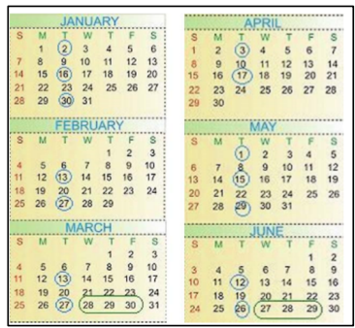

|  |  |  |  |
| --- | --- | --- | --- |
| **S.NO** | **DAYS** | **DESCRIPTION** | **SCHEDULE** |
| 1 | Business Day | These days are those when all the team mates work on the project in order to complete the project on time. Usually a sprint consists of 10 Business Days. | The dates within the circles indicates the various business days in each of the months since our project is very large we used many sprints to complete our project. |
| 2 | Development Day | It the day when we get all the inputs from the scrum master and owner and we develop the project on that particular day to our beneficial. | The dates in the above picture that are in ovals indicates the development day, since there were many developments mentioned we took many development days. |
| 3 | Deployment Day | It is the day when the project is deployed in to the real environment and we check whether the project is working up to the mark or not. | The dates that are mentioned in a void in the above picture indicates the deployment day i.e when the project is brought into the real time. |

1. **List few functional requirements:**

* Python - 2.7 or 3.9 version
* OpenCv - Face and eye detection
* Keras - To build our classification model
* Tensor Flow - Keras uses Tensor Flow as backend
* Pygame - To play alarm sound
* Dataset - shape_predictor_68_face_landmarks

1. **What metaphors would you suggest for your project? Explain why?**

* Driving Too Lazy! What does it tell you?

Metaphor is a type of literary form which indicates the inner meaning of the word or a sentence mentioned in the place of the main word. Thus I have chosen this metaphor because whenever a person is lazy he tends to feel sleepy for the maximum number of times, thus whenever the driver will feel drowsy this system will detect the eye aspect ratio of the driver’s eyes and blow out an alarm if the calculated EAR is less than the threshold EAR value.

1. Elaborate on the Time-Related Problems that you faced in your Project:

* Since there was very less time in order to complete the project and get the paper published we used the pre-existing code in order to complete the project on time.
* This pre-existing code consists of old techniques and old algorithms thus leading to take more time in order to complete the project.
* So we included new methods and algorithms such as Multi Task Cascaded Neural Networks and Eye Aspect Ratio which gradually increased the detection of the face and eyes in a much faster way.
* Also the submission time for the project was very less, so we had to work out our brains and complete the project in time.

1. 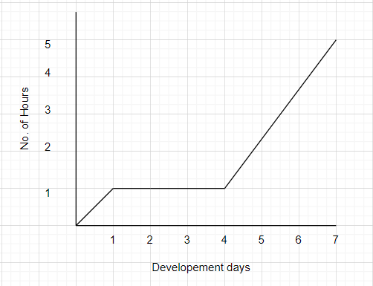Draw a graph describing the estimation development and actual development with development days in x –axis and no of hours your team worked on project on y- axis. There will definitely be a delay in the actual development, Explain why?

* There is an actual delay in the progress of our project because during the initial days of our project we worked only for an hour per day until four days which delayed our project but we covered up by working for 4-5 hours per day and completed our project in time.

1. **Define Quality with respect to your project and how do you measure it?**

* Quality in our project refers to how better our project identifies the person’s drowsiness and produce an alarm in order to alert him.
* In this study, we calculated the Eye Aspect Ratio to determine the driver's level of tiredness (EAR). If the computed ratio is less than the number that we previously established for the EAR, an alarm is activated, warning the driver.
* Even after the alert is activated, if the driver is dozing off, a second alarm that reflects the car's automated braking and sidelining system will also sound. This project might also be beneficial for those who use glasses and can recognize tiredness.
* We measure the quality of our project by testing it in various conditions such as the foggy conditions as well as dark conditions, and we also tested the accuracy of our project by using various deep learning techniques.

1. **Is your team diverse? If so, in what sense? Do you benefit from this diversity? If not, why? If so, how? If your team is not diverse, what is common to all the team members? Describe something specific.**

* Yes our team is diverse.
* In the sense that each and every one in our is specialized in either or the other fields. For example a person in our team is good at coding and the other person is good at the documentation and data collection and I am good at providing speeches or giving presentations regarding our project.
* Yes we were hugely benefitted from this type of diversity as a person good at documentation would not be good at coding or giving a presentation.
* A person knowing how to present the project would not know how to code the project and the person who know how to code the project might not know how to document the project or present the project. Thus this diversity has helped me a lot in the completion of our project.

1. **Describe a scenario that illustrates how diversity may harm agile teamwork. What characterizes such scenarios?**

* Sometimes during the progression of our project, most of the work will be depending upon the coding part of the project or the presentation part or the documentation part.
* If the team members are diversified, then most of the work must be done by one single person thus leading to stress and late submission of the task.
* In agile we have various sprints, and certain amount of work must be completed in that particular sprint time, but if only one particular person is working on that one particular task, then it is going to take long time to complete the task.
* Thus in such scenarios, diversity may harm agile team work, so in order to avoid such scenarios all the team members must take part in the completion of the work.

1. **Describe the learning that we have achieved from your overall project work?**

* We learned many things from the completion of this project some of them are listed below.
* We have learnt how to make use of the Multi Task Cascaded Convolution Neural Network, how many layers are present in it and how many have we used in our project.
* We have also learnt how to train the machine or a camera in order to capture the image of the driver and calculate the Eye-Aspect-Ratio.
* We have learnt how to make use of the various packages and libraries present in real world.